Title Page

Capstone Internship at PNC

by

Ayden Kauffman

University of Pittsburgh

2023

Table of Contents

1.0 Introduction to PNC and Enterprise Technology and Security 5

1.1 ET&S Advanced Analytics 5

1.2 DevOps Policy as Code (PaC) 6

2.0 Advanced Analytics Responsibility & Project 7

2.1 OKR Reporting Process 7

2.1.1 Objectives & Motivations 7

2.1.2 Implementation 8

2.1.3 Technical Challenges 10

2.1.4 Non-Technical Challenges 11

2.1.5 Outcome 11

2.1.5.1 Business Impact 12

2.2 Hot 100 Dashboard 12

2.2.1 Customized Numbering and Resetting the Number Count 13

2.3 Table Formatting 15

2.4 Updating the List of Figures or List of Tables 16

2.5 Cross-references for Linked Items 16

2.6 Permissions and Original Creations 17

Appendix A Appendices and Supplemental Content 18

Appendix A.1 Tables and Figures 18

Appendix A.1.1 Subsection Example and Appendix Captioning Advice 19

Appendix A.2 Adding Supplemental Documents 20

Bibliography 21

# Introduction to PNC and Enterprise Technology and Security

This summer I had the opportunity to intern at PNC, one of the nation’s leading financial services institutions which started right here in Pittsburgh. They have now grown to roughly 2,000 branches spanning operations into 27 states. Spending time at PNC provided me with a unique experience in interacting with both banking and technology. PNC’s technology department is divided into two separate divisions, the division I worked within was called Enterprise Technology & Security or ET&S. They were known as the foundation that all of PNC’s technology was built upon, practically speaking they handled the backend technologies at PNC. Over the course of the internship I had the opportunity to work alongside other professionals on real-world projects that had real impact on two separate teams within ET&S.

## ET&S Advanced Analytics

The first team I was assigned to was ET&S Advanced Analytics. I was on this team with one other intern. The team was formed roughly one year prior to my arrival at PNC with the main purpose of standing up a new dashboard for ET&S’ CTO Debbie Guild. The dashboard was named Hot 100 as it contained 100 metrics that Debbie Guild leveraged monthly to communicate with PNC’s CEO Bill Demchak. A portion of my responsibilities this summer were directly related to this dashboard, tasks I will discuss later, however at a high level it involved bug fixes, metric reworks, and data cleansing. However, our main responsibility was an overarching project for the 10 weeks which involved reworking an OKR (Objective Key Results) reporting process for the Strategic Insight and Value team also know as SI&V. SI&V had two interns on their team who merged with our team’s interns to create a team of four for this project. As a team of four we were given full ownership of this project and were completely responsible for the creation of the process. I will talk later in this paper about how it was done.

## DevOps Policy as Code (PaC)

The second team I worked for was a team apart of the DevOps department within ET&S called PaC or Policy as Code. Policy as Code’s main role was informing and enforcing policies on software projects of a certain size and assisting in setting up CI/CD pipeline that PaC monitors. All interns within PNC are assigned to a mentor who has previously completed an internship and is still working at PNC. My mentor was a member of this team and after hearing him discuss his work and what their team responsibilities encompasses, I reached to see if they had any work I could take on. I was given certain tasks and the ability to shadow my mentor in meetings which allowed me to learn a lot. Later in the paper I discuss my responsibilities.

# Advanced Analytics Responsibility & Project

## OKR Reporting Process

The OKR reporting process was previously being done in Tableau and Excel completely manually by the SI&V. PNC was pushing for wider implementation of OKRs for teams across the bank to better track progress and create more efficient budgeting and effort delegation. This push meant this process would need to be done in a more efficient way.

### Objectives & Motivations

The push for the expanded use of OKRs creates an obvious need to rework how things were being done. Having data providers input data into the same excel document with no control of where/what they can edit is far from optimal. This manual input into excel also required a manual upload of this data into Tableau. The current process was not scalable and would be bottleneck with many weak point in terms of security. The first step was creating a more efficient and secure way to store the data and allow for the input through a form. Ideally data providers are only able to input data on how the metrics within their segment are preforming and not be able to edit anything else without an approval process.

The process also had to be moved at of Tableau, Tableau licensing is not only required for the people building/editing the current dashboard, but a Tableau license is also required to view the dashboard. Each provision of a viewing license for Tableau was very costly. Everyone currently working at PNC is given a Microsoft license which includes PowerBI this means by transferring to PowerBI you’re saving a large sum of money.

Next, SI&V also had to manually chase data providers for their data. The current process was using manual email writing for deadline reminders, input access provisioning, and past due data request. Which created the last key objective for us of automating the emailing and access provision of the process.

### Implementation

In order to implement the Hot 100 Dashboard our team used a stack that include a PowerBI dashboard backed by a SharePoint List that stored the data. The expectation for our OKR Dashboard was to implement it using the same tech stack. However before beginning any of this the data must be pulled from Tableau and uploaded to SharePoint. To accomplish this I used SQL to query the data that was being used from a database and the rest was provided in one big Excel sheet. Once the data has been gathered our team of interns used Python to better structure this data in columns that would make the upload to Sharepoint much easier. This was required because when you upload data to Sharepoint the columns of the data must match the columns that are present in the separate Sharepoint lists.

Once the data was structured, the Sharepoint list had to be created. This is very similar to the process of creating database tables where each table holds certain attributes and number of rows. In terms of this process 3 separate list were created: Metric Directory, Intake, and Target history. Metric Directory stored general static information about metrics, intake acted as a running history and were each months inputted data would land, and lastly the Target history would store the history of the target of those OKRs. I found it to generally to not be the best tool we could have used on this project as it is not a proper database. I will dive further into the problems with SharePoint being used in this fashion later in the paper.

Once the data has been uploaded and all the lists populated within SharePoint the process of building out the dashboard begins. This task was divided between one other intern and I while the other two members worked on documenting the project so far in preparation for the transfer of ownership at the end of the summer. PowerBI has fantastic integrations for live data connections to power a dashboard. This is especially true for Sharepoint list due to the fact they both fall within the Microsoft suite. Once the data is pulled into PowerBI the data can be manipulated in Microsoft PowerQuery functions, these functions will run every time the data connection is refreshed so you only have to do it once and allows for the creation different calculated columns for the analysis. I am unable to speak about the different calculations we used for the analysis, but you can reference Figure 2A of the production dashboard below to get a general idea of what was done. Roughly 3 weeks were spent on building out the logic for the graphs in Python & DAX, these code lines can get very complicated or can be very simple. It was fulfilling to think out the logic of some of the more complicated tasks on the dashboard and was generally more enjoyable than at first glance.

**Figure 2A. OKR Dashboard built in PowerBI**

Once the dashboard was completed the next step was automating certain tasks. These automations were done in Power Automate using what are called “workflows”. The first task that was automated was the initial email that data providers received informing them that the intake period has began for their OKR metrics. This involved referencing the SharePoint list to pull data provider information and reference it to their Microsoft account so that 1. Access can be given for the Intake period and 2. They receive an email in outlook that informs them that the intake period has begun. The second automation I completed was the deadline reminder which was similar to the previous workflow but would just be sent out 1 day before the due date, on the due date, and every day after the due date.

### Technical Challenges

One of the major technical challenges that I referenced earlier in the paper was the use of SharePoint for data storage. SharePoint lacks a lot of the things that make relational database as powerful as they are. SharePoint does not allow for primary keys, foreign keys or practically referencing another table in any way, and constraints. This created concerns for the other interns and I as for long term storage of metric information the lack of these tools means bug fixing and data management of this list would be very challenging. Although we raised these concerns, we were asked to continue building out using SharePoint.

Another technical challenge was learning PowerBI. Before my time at PNC, I was not interested in data analysis in any way so learning the ins and outs of a data analysis platform like PowerBI was difficult. I lacked the personal motivation to push myself to learn data manipulation, creating efficient visualization and other task related to data analysis in PowerBI. However, when working with PowerBI in a practical business setting I found the motivation to push myself and create more complicated visualizations within PowerBI and eventually overcame this challenge.

### Non-Technical Challenges

The only non-technical Challenges I faced were in relation to contacting SI&V about their current process. The interns lacked access to view the current process/dashboard so communication about the current reporting process within Tableau had to be done through a SI&V team member. We found that it was very hard to get in contact with a member who had time on their schedule to speak with us and help us build out certain tasks. This lead to tasks being blocked for multiple days and leaving some portion of the project at a standstill.

### Outcome

#### Business Impact

## Hot 100 Dashboard

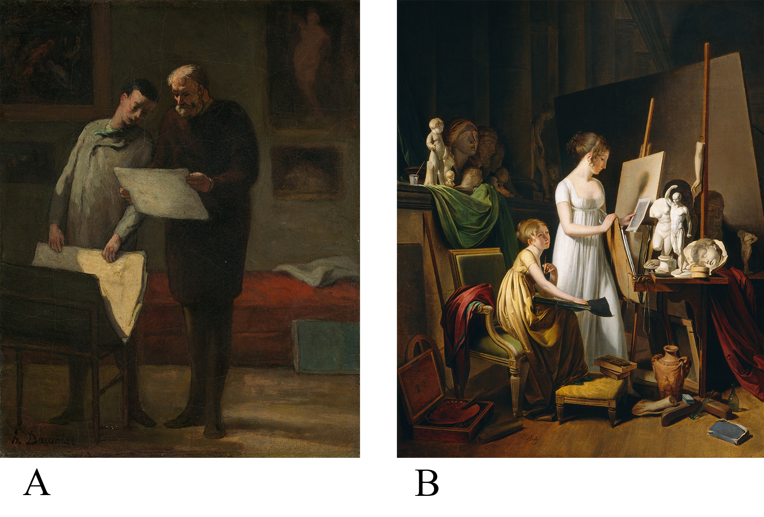

Figure 2A and 2B. Dipictions of artists in their studios.

Figure 2A shows. Honoré Daumier. (1865/1868). *Advice to a Young* Artist, 1865/1868. [oil on canvas]. National Gallery of Art, Washington D.C., USA. Whereas Figure 2B shows Jean-Baptiste-Camille Corot. (c. 1800). *A Painter’s Studio*. [oil on canvas]. National Gallery of Art, Washington D.C., USA

If you have a large caption description or other information relating to the figure/table, that you want to have appear all on one line as the caption, but not be included in the List of Figures/Tables; you will need to follow one of suggested methods. The first step is to enter a paragraph return where you want the main caption to end. Then put your cursor on the line of the extended caption or caption description. Then select the style Caption Description to no longer have that portion be associated with the same Caption style. If you are on a PC, put your cursor on the line with the main caption. Then press **Ctrl+Alt+Enter**. This will add a style separator.

If you are using a Mac, enter the paragraph return and style the extended caption as previously mentioned. Next click and highlight the paragraph return mark that follows the main caption. With that highlighted, open the Font menu on the Home ribbon. Select hidden under the effects section. When the PDF is generated, this mark will be hidden, and the line will appear as a continuous caption.

### Customized Numbering and Resetting the Number Count

There will sometimes be occasions that you need to restart the numbering of your figures or to add extra descriptors to the caption label. For instance, if you wanted to start a sequence of figures that were related and wished to express them as Figure 1A and Figure 1B; you will need to configure the sequence settings in the code behind that caption. Please follow this guide to learn how: [Advanced Caption Numbering Solutions](https://pitt.libguides.com/c.php?g=845948&p=8645727). However, you can also add text to your caption labels and have it show up in your List of Figures, as long as you don’t’ delete the number sequencer.



Figure 3A. A graph made from building blocks.



Figure 3B. A graph made from colored pencils.

You can often add customized descriptions to your captions, but you need to make sure to have inserted them using the Insert Caption command first.

## Table Formatting

A table is generally a set of facts or figures systematically displayed in columns and rows. There aren’t any defined formatting rules for tables. Be sure to use a font family that is easy to read and a font weight that isn’t too small to understand when your ETD will be in microform format. The use of color is acceptable but be mindful of using any cell shading values that may be similar to the font color.

Table 1 Captions Go Above for Tables

|  |  |  |
| --- | --- | --- |
| Particle | Discoverer | Year of Discovery |
| Electron | Joseph J. Thomson | 1897 |
| Proton | Ernest Rutherford | 1919 |
| Neutron | James Chadwick | 1932 |
| Positron | Carl D. Anderson | 1932 |

The table does not need to be inserted on the page where it is discussed in the text. If the table will not fit on the page where it is first mentioned, we strongly suggest that it either be on the next page or separated in a logical manner across the page break. You should use Page Breaks when possible, so that the table occurs at the top of the next page. Try to also organize the surrounding text to fill in the space that the table would have occupied in the previous page.

To add a caption, select the table using the table control box and then right-click to select Insert Caption. You can add caption descriptions after the table or directly after the caption, depending on your preference.

## Updating the List of Figures or List of Tables

When adding new table or figure captions, you will need to update the related lists manually. Return to the list of figures/tables in the preliminary section and right click (Ctrl+click on a Mac) on one of the listed items in the relative list. Then select Update Field – Update Entire Table, so that any new or edited content is reflected there. If you hover over any update listings and it appears as a file location on your hard drive and doesn’t show **CTRL+Click to Follow Link**, there is some issue occurring at the location of that caption. Please review our instructions for inserting captions and update the list after making those edits.

## Cross-references for Linked Items

It is often much easier to keep your links to features such as figures and tables or heading levels, by using the cross-reference feature under the References section. By using this feature you are able to create a reference link to the caption or heading you have inserted. The benefit of this feature is that if the numbering changes for the item being referenced, the cross-reference can also be updated throughout the document.

## Permissions and Original Creations

It is important to obtain permission to include any material that is copyrighted by someone else. This includes maps, drawings, tables, figures, photographs, sound files, and video clips, among others.

* + - * 1. Appendices and Supplemental Content

Appendices contain supplementary or illustrative material or explanatory data too lengthy to be included in the text or not immediately essential to the reader’s understanding of the text.

When using the Appendix Style, type the title of the Appendix section after the inserted heading. To insert a subsection in the Appendix, use the App Section Style to create each subsection and App Subsection for the third level within each main Appendix level.

Tables and Figures

To caption any tables or figures in your Appendices, you can continue to use the same caption labels that are in the main body of your ETD. However, you are able to add custom labels to differentiate your captions that are used in your Appendices.

A paragraph return symbol.

Appendix Figure 1 Paragraph Mark

Be sure to use the Appendix Figure or Appendix Table labels if you wish to start a new numbering format for these figures. If you want to continue the numbering sequence from the body of the tex, simply use the labels Figure or Table

To create alternate Appendix Figure/Table caption labels, begin by inserting a caption as you would for any other figure or table. Then use the new label button to specify a new label for the caption. You will need to either create a separate list of figures/tables for these labels or use the ETD formatting guide for creating custom Appendix labels. Please refer to our guide on creating custom labels found here: <https://pitt.libguides.com/etdsupport/captions>.

It's important to note that using the alternate numbering style that includes the chapter/heading numbers in the caption doesn’t function properly in the Appendices. You will need to create custom labels to have your captions appear as Figure A.1. Please contact ETD Support (<https://etd.pitt.edu/help>) for assistance in creating labels such as this.

Subsection Example and Appendix Captioning Advice

You aren’t required to create custom numbering sequences for your Appendix figures and tables. If you prefer to continue the figure and table numbering used in the body of your ETD, just add the same caption for figures or tables. The only issue that might come up is if you choose to adjust the numbering of your captions to include the chapter numbers. Because the Appendices aren’t technically using the same Heading hierarchy, they won’t continue the numbering for the body Headings. In this case, it might be best to use the custom caption labels and manually add the Appendix heading levels after creating the caption. You will then need to reset the Appendix caption numbering by following this guide: Advanced Caption Numbering Solutions. .

Appendix Table 1 Letters and Number

|  |  |  |  |
| --- | --- | --- | --- |
| **Letters** | **Numbers** | **More Letters** | **More Numbers** |
| efg | 456 | efg | 456 |
| hij | 789 | hij | 789 |
| abc | 123 | abc | 123 |

Appendix Table 1 Letters and Number (continued)

|  |  |  |  |
| --- | --- | --- | --- |
| **Letters** | **Numbers** | **More Letters** | **More Numbers** |
| hij | 789 | hij | 789 |
| abc | 123 | abc | 123 |
| efg | 456 | efg | 456 |
| hij | 789 | hij | 789 |

Adding Supplemental Documents

To add supplemental documents such as letters, survey forms, or published articles; it is not advised to try and embed the PDF versions or these files. You may want to upload the supporting documents alongside your ETD PDF in D-Scholarship@Pitt and reference them in your Appendices. This allows you to preserve the format of the original document and allows you to include materials that may not be embedded in a Word document. Please refer to our guide on Adding [Supplemental Files and Research Data - Electronic Theses and Dissertations Support Guide - LibGuides at University of Pittsburgh](https://pitt.libguides.com/etdsupport/supplementalfiles).

# Bibliography

To enter references for your work use the Bibliography Entry style. Single-spaced within entries. Usually ‘hanging’ from the second line on, like this. The default format will be block justified but you can make the entries left justified if desired. (The latter often helps URLs not cause spacing issues.)

Here are some examples from different styles.

Author's last name, first name. Book title. Additional information. City of publication: Publishing company, publication date. [MLA]

Author's last name, first initial. (Publication date). Book title. Additional information. City of publication: Publishing company.

Author’s last name, first name. "Title." Journal Title. Volume number, Issue number. (Publication date): pages. [DOI](https://doi-org.exproxy.umuc.edu/10.1086/683541). [Chicago]

You can use discipline specific citation styles, but these should be consistent and accurately generated following the style guide most commonly used in your discipline.